# 1. NAPAS RECONCILED NEW VERSION 1.1

Napas reconcile include three service of napas payment system:

- Reconciled ISSUING ATM-POS and ISSUING ECOM

- Reconciled ACQ ATM- POS.

The below is the flow step to permanced the reconciled with payment system.

## 1.1 Napas Reconciled incomming file

Menu path: ROOT\ACB Production\Napas New Spec\ISS\POS-ATM\01_ACB.IMPORT NAPAS ISS-SWC-TC FILE.

Function: import the napas imcoming file to SML_DOC table then create the Fin transacion of credit card then import to document transaction.

Include 6 subiterm as below:

### 1.1.1 import imcomming javapipes:

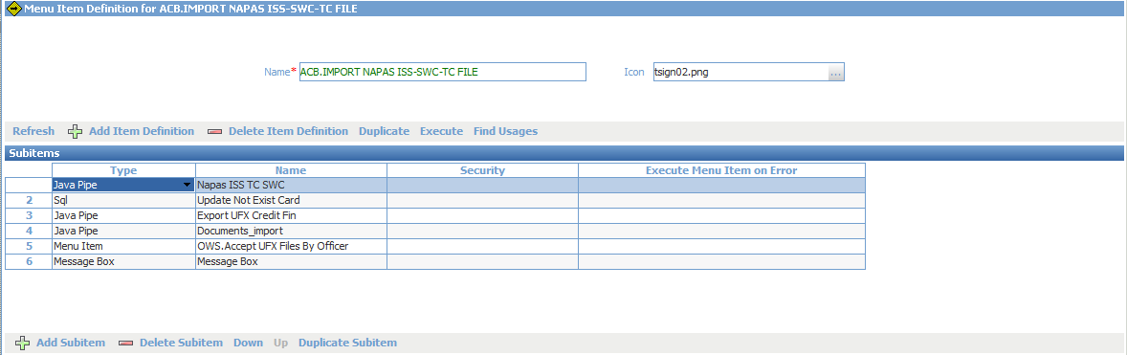

Javapipes name: com.openwaygroup.pipe.napasincoming.jar

|  |  |  |
| --- | --- | --- |
| Name | Value | Description |
| OUTPUT_DIR | <parameter name="INTERCHANGE_PATH" target="VARIABLE"/>/WAY4_INC |  |
| NAPAS_CHANNEL_CODE | B |  |
| BANK_PASSWORD | 970416 |  |
| CHECK_CHECKSUM | N |  |
| SOURCE_DIR | <parameter name="INTERCHANGE_PATH" target="VARIABLE"/>/ACB_INW |  |
| DIRECTION | ISS |  |
| ERROR_DIR | <parameter name="INTERCHANGE_PATH" target="VARIABLE"/>/ACB_ERR |  |
| PROCESSED_DIR | <parameter name="INTERCHANGE_PATH" target="VARIABLE"/>/ACB_ARCH |  |
| OUR_MEMBER_ID | 970416 |  |
| FILE_MASK | *ISS_ACB_*TC_SWC.dat |  |

### 1.1.2 Update status for the card not existing

|  |
| --- |
| update opt_smldoc dc set  dc.POSTING_STATUS = 'D',  dc.OUTWARD_STATUS = 'J',  dc.STATUS = 'NO CARD'  where  dc.POSTING_STATUS = 'P' AND  dc.Status='LOAD' and  trim(dc.File_Type) like 'NAPAS ISS-TC%' and  dc.Amnd_state='A' AND NOT EXISTS(  Select ID from acnt_contract where amnd_state='A' and contract_number=dc.target_number  and contract_name not like 'ACB_%' and contract_name not like 'MIG_%'  and base_relation is null  ) |

### 1.1.3 import financial document for credit card

Subiterm javapipes: com.openwaygroup.pipe.napasincomingfincredit.jar

Function: this subitem create xml document then import bath file to Doccument.

|  |  |  |
| --- | --- | --- |
| Name | Value | Description |
| OUTPUT_DIR | <parameter name="INTERCHANGE_PATH" target="VARIABLE"/>\way4_inc |  |
| CURRENT_USER | <parameter name="BUF" target="LOCAL_CONSTANT"/> |  |
| NAPAS_CHANNEL_CODE | b |  |
| PRODUCT_GROUP | ISSCR |  |
| DESCRIPTION | NAPAS INC |  |
| MEMBER_BANK_CODE | 970416 |  |
| FILE_TYPE | NAPAS ISS-TC-SWC |  |

### 1.1.4 subitern javapipes import document standard

- java pipe: com.openwaygroup.pipe.ic.documents_import.jar

- Function: after the xml file created and move to default folder: way4-inc then this subitem will be put data into Doc table by processed the import file.

|  |  |  |
| --- | --- | --- |
| Name | Value | Description |
| SOURCE_DIR | <parameter name="INTERCHANGE_PATH" target="VARIABLE"/>\WAY4_INC |  |
| ERROR_DIR | <parameter name="INTERCHANGE_PATH" target="VARIABLE"/>\WAY4_ERR |  |
| PROCESSING_SUSPENDED | Y |  |
| PROCESSED_DIR | <parameter name="INTERCHANGE_PATH" target="VARIABLE"/>\WAY4_ARCH |  |
| OUTPUT_DIRECTORY | <parameter name="INTERCHANGE_PATH" target="VARIABLE"/>\WAY4_OUT |  |
| FILE_MASK | *NAPAS_INCOMING_CREDIT*.xml |  |
| IC_CHANNEL | b |  |

### 1.1.5 Acceiptance document

This subitem is used to accepted for finacial document waiting state by the standard pipes.

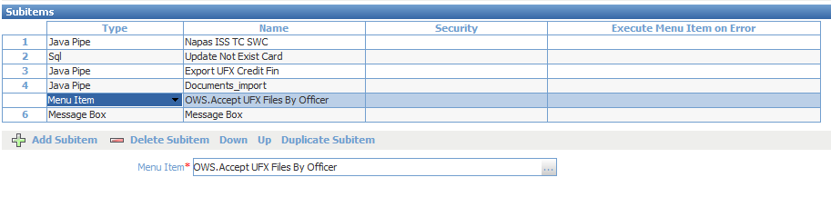

## 1.2 Napas reconciled ACK incomming import.

The menu performed import the transaction is the result of reconciled case by return code from Napas payment system. This step will be update the transaction case to SML_DIS table and decide to create the Fin reversal, unhold for credit card or ignore case. Below is the details subitem:

### 1.2.1 import incoming ACK file.

Javapipes name: com.openwaygroup.pipe.napasincoming.jar

|  |  |  |
| --- | --- | --- |
| Name | Value | Description |
| OUTPUT_DIR | <parameter name="INTERCHANGE_PATH" target="VARIABLE"/>/WAY4_INC |  |
| NAPAS_CHANNEL_CODE | b |  |
| BANK_PASSWORD | 970416 |  |
| CHECK_CHECKSUM | N |  |
| SOURCE_DIR | <parameter name="INTERCHANGE_PATH" target="VARIABLE"/>/ACB_INW |  |
| ERROR_DIR | <parameter name="INTERCHANGE_PATH" target="VARIABLE"/>/ACB_ERR |  |
| PROCESSED_DIR | <parameter name="INTERCHANGE_PATH" target="VARIABLE"/>/ACB_ARCH |  |
| OUR_MEMBER_ID | 970416 |  |
| FILE_MASK | *ISS_ACB_*XL_SWC.dat |  |

### 1.2.2 menu update ACK Case

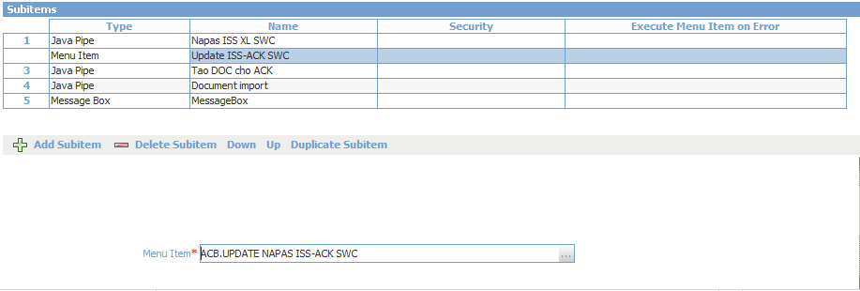

|  |  |
| --- | --- |
| Name update case | scripts |
| 3.1_Update for card not exist in Way4 |  |
| 3.2_Update for OUT 116 - ACK 111 |  |
| 3.3_Update for OUT 116 - ACK 110 |  |
| 3.4_Update for OUT 116 - ACK 119 |  |
| 3.5_Update for OUT 117 - ACK 113 |  |
| 3.6_Update for OUT 117 - ACK 112 |  |
| 3.7_Update for OUT 117 - ACK 119 |  |
| 3.8_Update for ACK 110 |  |
| 3.9_Update for ACK 115-113 |  |
| 3.10_Update for ACK 114-112 |  |

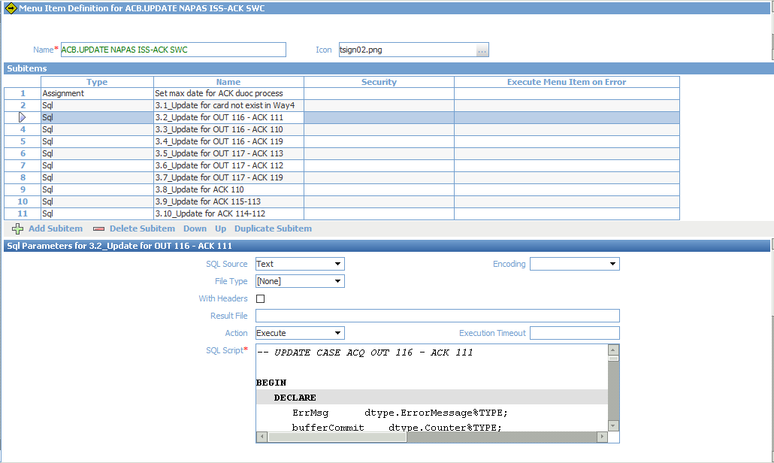

### 1.2.3 Create financial document to update case

Pipes: com.openwaygroup.pipe.napasackuploadswc.jar

|  |  |  |
| --- | --- | --- |
| Name | Value | Description |
| OUTPUT_DIR | <parameter name="INTERCHANGE_PATH" target="VARIABLE"/>/WAY4_INC |  |
| NAPAS_CHANNEL_CODE | b |  |
| DESCRIPTION | NAPAS ACK |  |
| MEMBER_BANK_CODE | 970467 |  |
| FILE_TYPE | NAPAS ISS-XL-SWC |  |
| DIRECTION | ISS |  |

### 1.2.4 Import document to Way4

- javapipes: com.openwaygroup.pipe.ic.documents_import.jar

- Function: after the xml file created and move to default folder: way4-inc then this sub-item will be put data into Doc table by processed the import file.

|  |  |  |
| --- | --- | --- |
| Name | Value | Description |
| SOURCE_DIR | <parameter name="INTERCHANGE_PATH" target="VARIABLE"/>\WAY4_INC |  |
| ERROR_DIR | <parameter name="INTERCHANGE_PATH" target="VARIABLE"/>\WAY4_ERR |  |
| PROCESSING_SUSPENDED | Y |  |
| PROCESSED_DIR | <parameter name="INTERCHANGE_PATH" target="VARIABLE"/>\WAY4_ARCH |  |
| OUTPUT_DIRECTORY | <parameter name="INTERCHANGE_PATH" target="VARIABLE"/>\WAY4_OUT |  |
| FILE_MASK | *NAPAS_ACK*.xml |  |
| IC_CHANNEL | b |  |

## 1.3. Reconciled menu

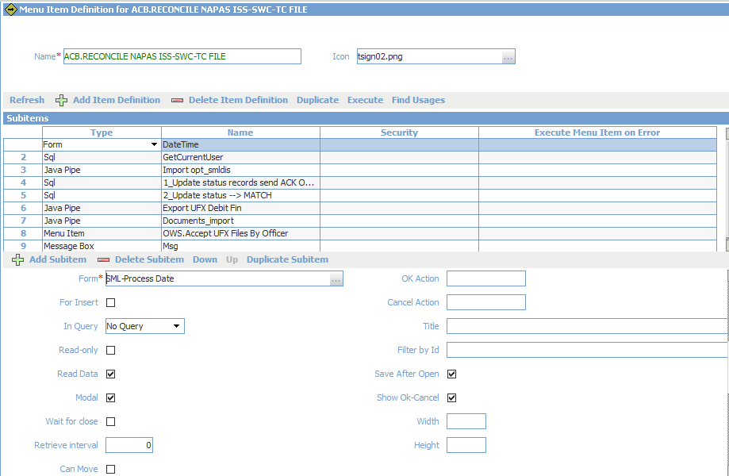

The menu include the nine submenu item for performing reconcile function.

### 1.3.1 set processing date for menu

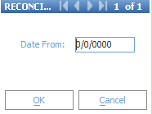

### 1.3.2 User process subitem

|  |
| --- |
| UPDATE V_LOCAL_CONSTANTS v  SET BUF = (SELECT officer.name  from officer where officer.id = v.amnd_officer) |

1.3.3 Reconciled

This submenu is calling the javapipes performaced the reconciled by send the script to database oracle the selection the case. If the list of case is existing then import to SML_DIS table.

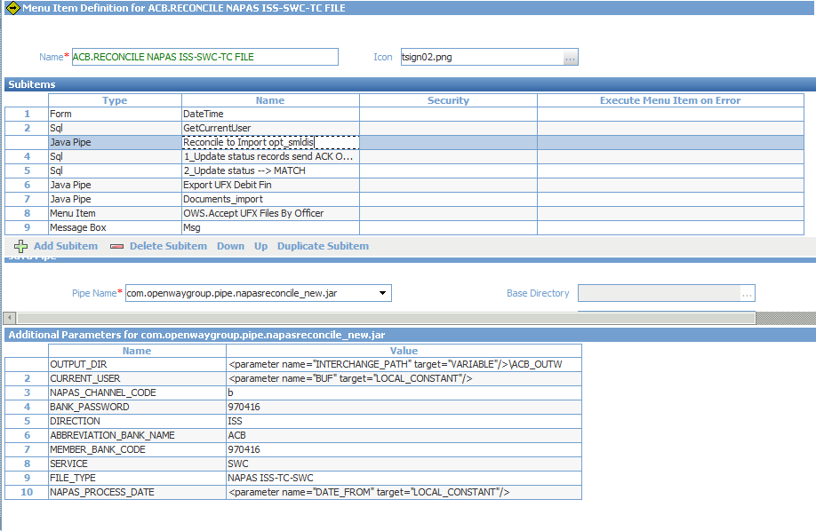

Javapipe name: reconciled_new.jar with the list additional parm:

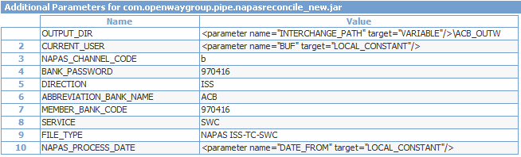

### 1.3.4 update status for transaction sent to dispute.

|  |
| --- |
| update opt_smldoc dc set  dc.Status='SENT',  dc.posting_status='D'  where  dc.amnd_state='A' and  dc.posting_status = 'P' and  dc.Status='LOAD' and  dc.id in(select s.doc__oid  from opt_smldis s  where  trim(s.process_date) =(select SUBSTR(TO_CHAR(DATE_FROM),0,10) from v_local_constants) and trim(s.direction)='ISS') |

### 1.3.5 update Match transaction

|  |
| --- |
| update opt_smldoc dc set  dc.Status='MATCHED'  where  dc.posting_status = 'P' and  dc.amnd_state='A' and  dc.Status='LOAD' and  dc.File_Type = 'NAPAS ISS-TC-SWC' and  trim(dc.process_date) = (select SUBSTR(TO_CHAR(DATE_FROM),0,10) from v_local_constants) |

1.3.6 create financial document for debit account export to dispute.

Javapipes name: com.openwaygroup.pipe.napasincomingfindebit.jar

Function: get the transaction dipute then create financial document anh debit account before send to dipute with payment system.

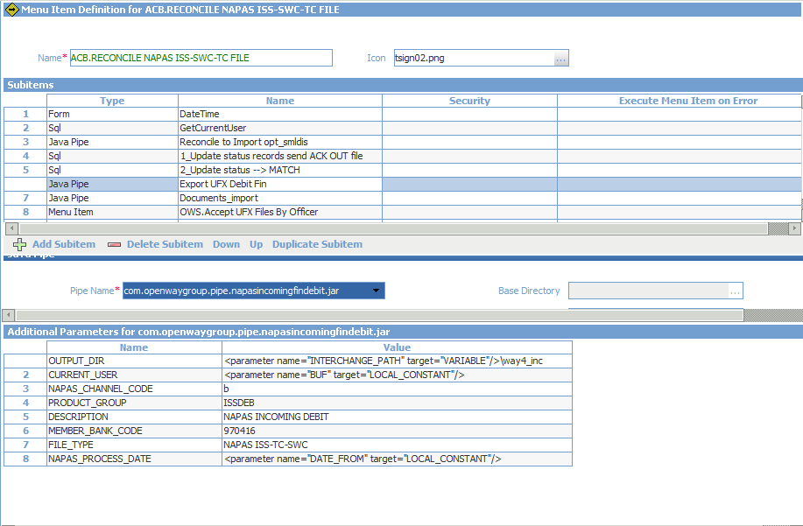

### 1.3.7 import doccument and acceiptance document.

The step 7,8 below this submenu item is acceipted document.

## 1.4 Export dispute transaction

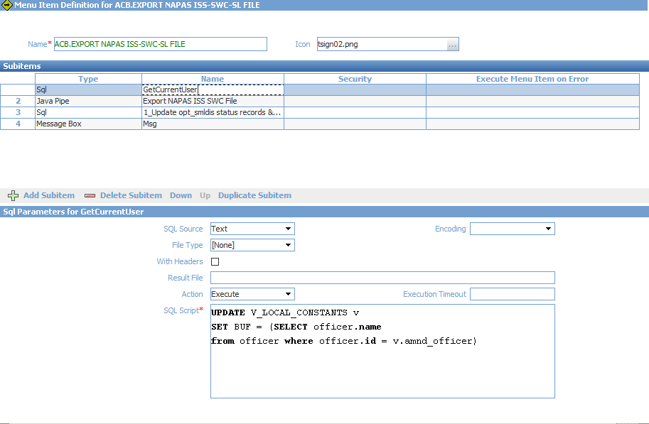

### 1.4.1 set user process

|  |
| --- |
| UPDATE V_LOCAL_CONSTANTS v  SET BUF = (SELECT officer.name  from officer where officer.id = v.amnd_officer) |

### 1.4.2 Export transacion

This submenu call the [com.openwaygroup.pipe.napasoutgoing.jar] javapipes to select the transacion needed dispute with payment system then export to .txt format.

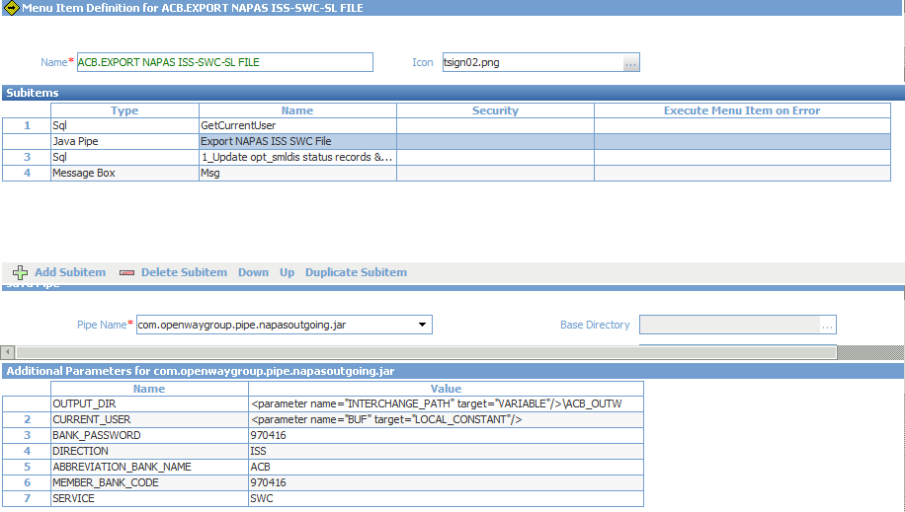

|  |  |  |
| --- | --- | --- |
| Name | Value | Description |
| OUTPUT_DIR | <parameter name="INTERCHANGE_PATH" target="VARIABLE"/>\ACB_OUTW |  |
| CURRENT_USER | <parameter name="BUF" target="LOCAL_CONSTANT"/> |  |
| BANK_PASSWORD | 970416 |  |
| DIRECTION | ISS |  |
| ABBREVIATION_BANK_NAME | ACB |  |
| MEMBER_BANK_CODE | 970416 |  |
| SERVICE | SWC |  |

### 1.4.3 Update status outgoing record

The sql update script:

|  |
| --- |
| update opt_smldis dc set  dc.Status='SENT',  dc.outward_date = (select to_char(local_date,'yyyy-MM-dd') banking_date from f_i where id = 745 and amnd_state = 'A')  where  dc.amnd_state='A' and  dc.Status='TO BE SENT' and  upper(trim(dc.napas_service)) = 'SWC' and  /*trim(dc.process_date) =(select SUBSTR(TO_CHAR(DATE_FROM),0,10) from v_local_constants) and */  trim(dc.direction)='ISS' |

